Product overview

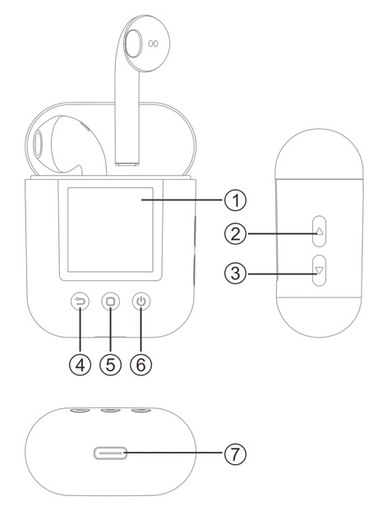 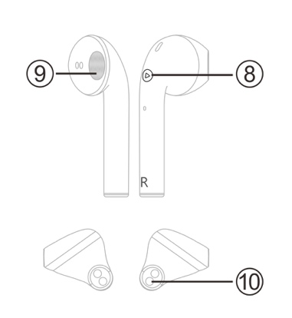

|  |  |
| --- | --- |
| 1. Display screen  2. Volume + button  3. Volume - button  4. Back button  5. Menu button | 6. Power button  7. Type-C port for charging/wired headphone/data transfer  8. Function button  9. Speaker  10. Charging pin |

Basic operations

**Power on/off**

Press and hold the  button for 3 seconds to power the player on or off.

**Access main menu**

Press the  button to enter the main menu interface, and press the   button on the side of the player to navigate the menu options. Press the  button to return to the previous menu screen.

**Volume adjustment**

In the music play interface, press the  button to increase the volume and press the  button to decrease the volume.

**Play/pause**

In the music play interface, press the  button to start or pause play.

Bluetooth connection

**Auto pairing of earbuds**

Remove the earbuds from the charging case, and the earbuds switch on automatically.

The indicators on both earbuds flash blue and red, indicating that the earbuds are pairing with each other. When the pairing completes automatically, the indicator on one earbud flashes red and blue alternatively, and simultaneously a voice prompt for successful pairing can be heard.

**Note:**

If the earbuds are removed from the charging case and no indicator on the earbud lights up, press and hold the  buttons on both earbuds simultaneously for three seconds to enter pairing mode. When the pairing completes, the indicator on one earbud flashes red and blue alternatively, and simultaneously a voice prompt for successful pairing can be heard

**Pairing with smartphone**

Make sure the earbuds are switched on and paired.

On your smartphone, activate Bluetooth function, search and select “TWM-850” from Bluetooth device list to connect the earbuds to your smartphone. After successful pairing, you can listen to music from your smartphone through the earbuds, and use hands-free call function through the earbuds.

**Note:**

Once paired, the earbuds and your smartphone are connected automatically each time the two are switched on and Bluetooth is enabled. If the earbuds and your smartphone cannot be reconnected automatically, go to the Bluetooth settings of your smartphone to search and select “TWM-850” for re-connection.

**Pairing with the player**

1. Press and hold the  button to switch the player on, and press the   button to select the Bluetooth menu.
2. Press the  button to enter the Bluetooth function interface, then press and hold the  button to search for nearby Bluetooth devices.
3. Press the   button to select “TWM-850” from the Bluetooth device list, then press the  button to confirm connection.

If you want to connect the player to other Bluetooth devices (e.g. a smartphone), repeat the steps above.“

**Manually reconnected to Bluetooth device**

When the player is switched on, press and hold the  button to enter the list of the connected devices, then press the   button to select a device to re-connect with the player, and press the  button to confirm connection.

**Note:**

If Bluetooth is disconnected (e.g. switch off the earbuds by holding down the  button on the earbuds), to reconnect Bluetooth, switch the earbuds on, then go to the Bluetooth settings of the player to reconnect the earbuds to the player.

Functions

**Music**

In the main menu interface, enter the music function interface. Press the  button to display the music file list, then select a music file to start play. Press the  button to play or pause when Bluetooth connection is made.

Press the  button on the earbuds to start or pause play. Press the  button twice to skip to a next song.

Press and hold the  button to access the following submenu options: directory list, repeat play mode setting, play control setting, EQ selection, user EQ adjustment, repeat A-B. Select an option, the press the  button to confirm.

**Browser**

Enter the browser function interface to display the player's stored file content directory. Select a file and press the  button to confirm. Press and hold the  button to display sub-options of file deletion and file management.

**Recording**

Press the  button to enter the recording function interface. The  icon indicates readiness for recording. The  icon indicates the progress of recording. Press the  button to start or pause recording. Press the  button to save the recorded file and return to the main menu interface.

Press and hold the  button to display sub-options of selecting file quality for recording.

**FM Radio**

Enter the radio function interface. Press briefly or hold down the   button to manually adjust the radio frequency. Press and hold the  button to enter the following sub-options: FM Region, Manual, Preset, Memory, Deletion and Auto.

**Pedometer**

Enter the pedometer function interface to display the following options: "” (steps), "" (distance), "" (calorie), "" (speed), "" (time).

Press the  button to start or stop counting steps.

Press and hold the  button to display the history, walk and running mode settings.

**Clock**

Enter the clock function interface. The time and date will be displayed on the screen. To time and date, go to the setting function interface.

**Chang settings**

Enter the setting function interface. The settings interface displays the following options: Bluetooth switching, Interface styles, Time, Backlight time, Brightness, Sleep time, Language, Step profile, About, Upgrade, and Default Set.

1. Bluetooth switching: When earbuds Bluetooth connection is made and you enter the functions of recording, e-book and picture browsing, you are prompted to disable Bluetooth connection before you can access the functions mentioned above. When using wired earphones, you may also disable Bluetooth connection to lower power consumption.
2. Step profile: You can set personal weight and step length, so that the parameters such as travelling distance, calories and speed can be more accurately calculated.
3. Interface style: There are two main menu interface types for you to select.
4. System time: You can set time and date. In the time setting interface, press the  button to select individual time and date items, then press the   button to change corresponding values. After all values are set, press the  button to confirm the settings.
5. Sleep function: You can set a time at which the player will switch off automatically.

**Using wired earphones**

You can connect wired earphones (not included) to the Type-C plug of the player to listen to music or radio.

Troubleshooting

|  |  |
| --- | --- |
| Cannot switch On | Low battery. Charge the product. |
|  |  |
| Disordered display text | Confirm whether your language is correctly selected. |
| FM radio signal not clear | Confirm whether there is any electrical interference nearby. |
| Cannot download music normally | 1. Confirm whether the USB cable is damaged, and the cable connection is secure. 2. Confirm whether there is enough space for storage. |
| Cannot connect to Bluetooth | 1. Check whether Bluetooth function is enabled. If not, enable Bluetooth function. 2. Select the corresponding Bluetooth device for connection from the Bluetooth device list. 3. If the device to be connected is disabled with Bluetooth or connected to other Bluetooth device, Bluetooth connection is not possible. |

Please notice - All products are subject to change without any notice. We take reservations for errors and omissions in the manual.

ALL RIGHTS RESERVED, COPYRIGHT DENVER ELECTRONICS A/S



Electric and electronic equipment and included batteries contains materials, components and substances that can be hazardous to your health and the environment, if the waste material (discarded electric and electronic equipment and batteries) is not handled correctly.

Electric and electronic equipment and batteries is marked with the crossed out trash can symbol, seen above. This symbol signifies that electric and electronic equipment and batteries should not be disposed of with other household waste, but should be disposed of separately.

As the end user it is important that you submit your used batteries to the appropriate and designated facility. In this manner you make sure that the batteries are recycled in accordance with legislature and will not harm the environment.

All cities have established collection points, where electric and electronic equipment and batteries can either be submitted free of charge at recycling stations and other collection sites, or be collected from the households. Additional information is available at the technical department of your city.

Hereby, Inter Sales A/S declares that the radio equipment type TWM-850 is in compliance with Directive 2014/53/EU. The full text of the EU declaration of conformity is available at the following internet address: www.denver-electronics.com and then click the search ICON on topline of website. Write model number: TWM-850. Now enter product page, and red directive is found under downloads/other downloads.

Operating Frequency Range:

Max Output Power:

DENVER ELECTRONICS A/S

Omega 5A, Soeften

DK-8382 Hinnerup

Denmark

[www.facebook.com/denverelectronics](http://www.facebook.com/denverelectronics)