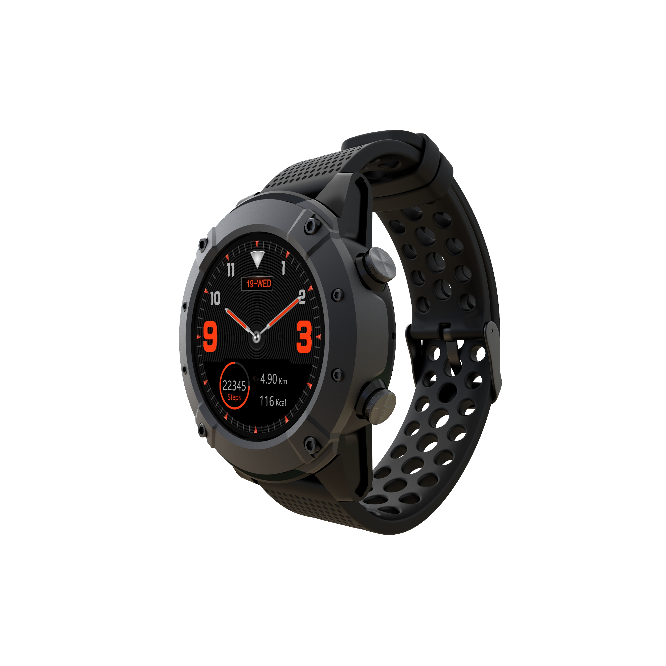

DENVER SW-650 GPS+GLONASS

smart watch

User manual

**System requirements**

The watch supports Android 4.4, iOS 8.0, Bluetooth 4.0 and above.

**How to charge battery**

Before start using the smart watch, please make sure the battery is charged. For charging, please use the provided magnet charging cable. The recommended power adaptor current is 5V, 1A.

It takes about 3 hours to fully charge the smart watch, please follow the steps below to charge.

* Put the charging cable beneath the watch
* Make sure the POGO pins on the cable fit correctly onto the charging terminals on the back of the watch.
* If correctly placed, the pins will stick to the charging terminals on the back of the watch.
* Then connect the charging cable to the power source with the USB connector.



**Environment**

Please don’t wear the smart watch when taking a hot shower or bath. Don’t use the watch in very high and low temperature environment. Otherwise, it may damage the watch.

**Basic operation**

* Turn on: long press the power button for 3 seconds.
* Access sport modes: swipe from right to left on the watch face, or press the top key.
* Navigate functions in the main menu: swipe up/down or vice versa on the screen.
* Access the function menu: swipe from right to left on the screen.
* Confirm selection: tap the icon on the screen.
* Exit/back: swipe from left to right on the screen.
* Return to the watch face: short press the power button on any screen.
* Sport mode shortcut: press the upper button
* Check notifications: swipe from left to right on the watch face.
* Switch submenu/shortcut: swipe up/down on the screen.
* Turn off: long press the power button for 3 seconds.
* For more accurate measurement, it is recommended to wear the watch around 1 cm behind the ulnar styloid joint, and close to the skin.

**Overview**



1. Shortcut key for Sport mode/ back
2. Power button
3. Touch screen
4. Speaker
5. Charging terminals
6. Microphone
7. Heart rate sensor

**Pair the watch with smartphone**

Mobile phones requirement: Android 4.4 and above; iOS8.0 and above.

Search and download “**Denver SW-650**” app from App store, or Google Play Store on your smart phone. Or scan the following QR code to install the app.



Make sure your smart phone is set to be “Detectable to all nearby Bluetooth devices”.

Step 1: Pairing for calling function

1. On the Bluetooth settings of your smart phone, activate Bluetooth and turn on the option of “Detectable to all nearby Bluetooth devices
2. Enable Bluetooth device searching.
3. Select “**SW-650**” from the list of devices for connection
4. If the connection is successful, “Connected” appears next to **SW-650** device name.



On the Bluetooth settings of the smart watch, the checking mark for Bluetooth connectivity appears next to the name of your phone.



The Bluetooth icon on the watch screen changes to blue .

1. After the successful initial pairing, the watch will automatically connect with your phone, and the watch will automatically synchronize date and time with your phone. You can also connect the smart watch with your phone via the menu option of the watch.

Step 2: Pairing through the “**Denver SW-650**” app to synchronize data and notifications etc.

1. Pair the watch with your smartphone as described in step 1.
2. Open the Fundo app on your smart phone, and tap “More” in the bottom right corner.
3. Tap “Add device” on the top.
4. Select and tap **SW-650** to connect.
5. If the connection is successful, “Connected” appears next to **SW-650** device name, and the app will synchronize data from the smart watch.



The Bluetooth icon on the watch screen shows both blue and green.

Your phone is now connected to the watch and you are free to explore all the functions of the watch in the various interfaces, directly by swiping the touch screen of the watch.

For the full user manual in English, please visit our website and find the product “SW-650” at [www.denver-electronics.com](http://www.denver-electronics.com)

ALL RIGHTS RESERVED, COPYRIGHT DENVER ELECTRONICS A/S



Electric and electronic equipment and included batteries contains materials, components and substances that can be hazardous to your health and the environment, if the waste material (discarded electric and electronic equipment and batteries) is not handled correctly.

Electric and electronic equipment and batteries is marked with the crossed out trash can symbol, seen below. This symbol signifies that electric and electronic equipment and batteries should not be disposed of with other household waste, but should be disposed of separately.

As the end user it is important that you submit your used batteries to the appropriate and designated facility. In this manner you make sure that the batteries are recycled in accordance with legislature and will not harm the environment.

All cities have established collection points, where electric and electronic equipment and batteries can either be submitted free of charge at recycling stations and other collection sites, or be collected from the households. Additional information is available at the technical department of your city.

Hereby, Inter Sales A/S declares that the radio equipment type SW-650 is in compliance with Directive 2014/53/EU. The full text of the EU declaration of conformity is available at the following internet address: <http://www.denver-electronics.com/denver-sw-650/>

Operating Frequency Range: 158MHz

Max Output Power: 0.65W

**Warning Lithium battery inside**

DENVER ELECTRONICS A/S

Omega 5A, Soeften

DK-8382 Hinnerup

Denmark

[www.facebook.com/denverelectronics](http://www.facebook.com/denverelectronics)